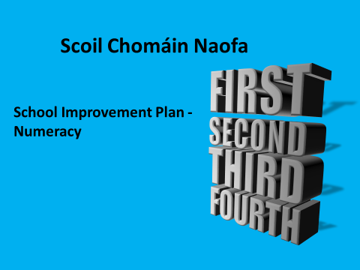
Scoil Chomáin Naofa School Improvement Plan for Numeracy
Baseline data | - Information examined from Standardised Testing – Sigma T Testing; End-of-term tests.  - Parent & Pupil feedback from surveys on Numeracy  - Teachers Mental Maths Survey  - Children’s copies, tasks etc, & teacher observation  - Staff dialogue
Strengths: | Based on analysis of the data above the following conclusions are drawn in relation to attainment of curriculum objectives in Numeracy:  Analysis of standardised test data over the past year along with evidence elicited through parent/student surveys and teacher input indicate that the area of Fractions appears to pose difficulty at many levels and requires a targeted approach  - Throughout all classes analysis of Standardised Tests indicates that over the past year over 45% of pupils performed between the STens of 8-10. Also 85% of pupils scored above a STen of 5.  - The data indicates that the number of children performing in the low to mid STen bands is either below the normal levels while the number of children performing in the upper 8-10 STen band is significantly above the normal level.  - Our pupil survey indicated that 73% had a very positive attitude to Maths, 58% felt confident in their ability at Maths and 32% felt they would like to spend more time learning Maths indicating the subjects importance.  - Over 47 % of parents indicated that their children had a positive attitude to Mathematics and were progressing well. 51% felt they knew their children’s strengths in Maths.  Pupils engagement in Learning:  - Children are generally confident and motivated regardless of their ability level.  - Teacher, pupil and parent surveys indicate that 88% of pupils engage readily with Maths ICT’s and these generally act as a motivational factor in the teaching of Maths.
Areas requiring improvements | - A limited range of concrete materials and resources are used by teachers in the classroom at all levels.  - 53% of parents say they would like to receive more information from the school regarding their child’s  progress.  - Teachers feel that the Number Strand should be prioritised.  - 60% believe that opportunities are not provided for all children including those with maths difficulties to partake in mental maths activities and that developing counting and reasoning strategies before moving on to fact mastery needs attention.  - All teachers agree the maths skills are regularly not taught in mental maths lessons except for recalling fact. Allowing the pupils opportunities to share their strategies for working out mental calculations needs attention.  - All teachers report that most children find fractions very challenging.  - 42% of the pupils reported that they found the number strand Fractions difficult.  - Teachers feel that problem solving is a skill that needs to be actively taught.  - The development of Mathematical trails within and outside of the school building should be further explored.  - The language of maths is actively modelled by teachers at all levels and its importance is emphasised however, teachers feel that maths language needs to be standardised throughout the school.  - Children should be given more opportunities to present or display their mathematical work in the class/corridor/ school.

Targets | Required Actions | Persons Responsible | Success Criteria / Measurable Outcomes | Review Dates
Decrease the number of children in STens 4 and 5 by 1% annually  To decrease the number of children who report difficulties in the areas of Fractions from 42% to 38% within a 3 year period  For each child to increase their score in the Ballard/ Westwood Timed Tables Test by 2 | Year 1 | Class Teachers and Principal | Standardised testing | Start Date:  1st Sept. 2015  Review Date  June 2016
 | Inventory of whole school maths resources and ordering of same if needed
 | Organisation of resources for the teaching and learning of fractions, mental maths and early mathematical activities for each class grouping | Class Teachers and Principal | Pupil survey  Staff meetings/ Board meetings re: targets
 | Each teacher to have hard copy of pdst handbook ‘Mental Maths‘ | Principal/ Numeracy link teacher
 | Inservice Whole School Seminar –  Mental Maths | All Staff – CP hours CPD | Results from Ballard Westwood test
 | Familiarisation with the common  fundamental facts about Mental Maths | Class Teachers | Teacher Planning
 | Familiarisation with Ready, Set, Go- Maths for early numeracy skills | Class Teachers | Teacher Planning
 | Teachers to provide opportunities for pupils to engage in mental maths activities on a daily basis where possible | Class Teachers & Numeracy Link teacher | Teacher Planning
 | Year 2
 | Review and monitor progress to date | Class teacher and Principal
 | Each teacher to have hard copy of PDST handbook ‘Fractions’ | Numeracy link teacher
 | Familiarisation with the common  fundamental facts about Fractions | Class teachers | Teacher Planning
 | Continuation of Mental Maths strategies to include multiplication and division in the senior classes | Class teachers | Teacher Planning
 | Continue to give the Ballard/Westwood tables test throughout the school. | Class teachers | Teacher Planning
 | Year 3
 | Review and monitor progress to date
 | Each classroom to have a Maths display board | All staff
 | Teachers model appropriate language in eliciting, supporting and extending pupil’s mathematical thinking | Principal and class teachers
 | Continue to give the Ballard/Westwood tables test throughout the school | Class teachers | Teacher Planning
 | To be added to after review of previous years | Class teachers | Teacher Planning

Reviewed by Board of Management on: 8th June 2015

Signed:
Chairperson
______________________

Principal
______________________

