Topmarks - Maths ( Excellent for Maths)

Hit the Button ( Quickfire maths)

Daily Ten - Mental Maths Challenge- Highly Recommend

Topmarks Homepage ( This is great for all subjects)

P.E with Joe-A daily workout from Monday-Friday 9 a.m.
https://www.youtube.com/playlist?list=PLyCLoPd4VxBvQafyve889qVcPxYEjdSTl

EPIC - We will be using this every day
https://www.getepic.com/sign-in/educator
All Levels

Epic! is an online library which offers over 35000 resources including “Read to Me” books, audiobooks, student tracking, reading level linkage with Accelerated Reader and other reading levelling schemes. It also offers high interest texts such as National Geographic Kids and Guinness Book of Records. It is suitable for children from ages 4-12.

Twinkl
All Classes
Twinkl are offering all parents and teachers a One Month FREE Ultimate Membership to Twinkl.ie. This will allow parents and teachers unlimited access to every single resource for every single curriculum subject from junior infants to sixth class.

www.twinkl.ie/offer
Notes: Setting this up is really easy to do - go to www.twinkl.ie/offer and enter the code IRLTWINKLHELPS.

Oxford Owl Ebook Reader Library
Junior Classes

Oxford Owl has an ebook library with over 250 books in it and offers free access to teachers and parents once you create an account at www.oxfordowl.co.uk They also have some vocabulary and comprehension activities for most of the books.

www.oxfordowl.co.uk

www.sorchaj.com
Infants to Fifth Class
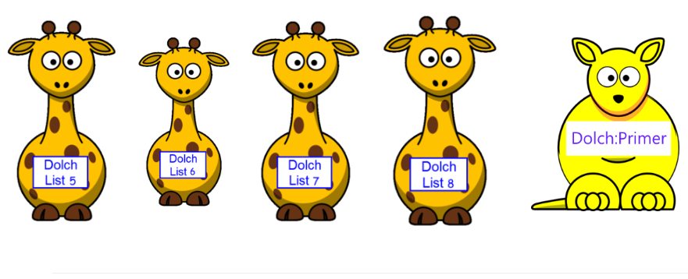
This site covers phonics, dolch, Jolly Phonics including tricky word lists and practice reading sentences following the Spellbound order of words and more.

www.sorchaj.com

Teach Your Monster to Read
Infants to 1st Class.
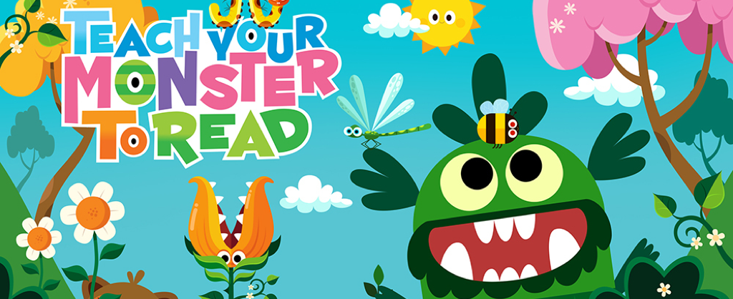
Teach Your Monster to Read is a fun activity that helps infants work on everything from initial sounds, CVC words, blends and digraphs all the way to full words and sentences. The Web platform is free for teachers and students (the App costs, but is not necessary). Teachers can set up a class quite easily and can simplify passwords. Great fun game that children can engage with at home (although teachers cannot set sounds - pupils work through independently).

https://www.teachyourmonstertoread.com/

